Huynh Anh Triet
Programer

1) OVERVIEW
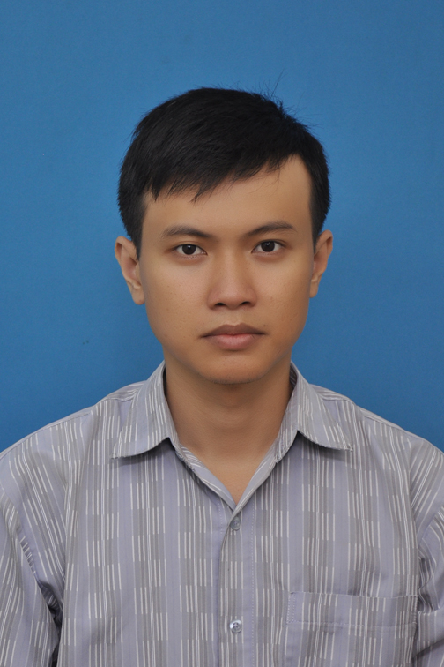
Full name: | Huynh Anh Triet
Date of Bird: | 10/08/1989
Sex: | Male
Marital Status: | Not Married
Nationality: | Vietnamese
Mobile: | 0374378179
Email: | huynh.a.triet@gmail.com
Current salary: | $800 NET
Expected salary: | deal
Availability: | 10 days required upon confirmation of offer

2)CAREER OBJECTIVES
- Try to learning as much as possible and doing my best in order to accompish my task
- To have good opportunities to get promotion in my job
- Developer android apps
- Developer game use unity or cocos2dx

3) TECHNICAL SKILLS

OS | Windows XP, Windows 7
Programming Languages | C/C++, PHP, Java/J2EE, HTML/XML, JavaScript , C#
Databases | MS SQL Server
Comms & Networks | TCP/IP, UDP, Socket
Packages | MS Visual Studio, MS Office , Eclipse, Android studio, Unity, Cocos2dx
Language | Java,PHP, ASP.NET, ASP.NET MVC, Android

4) EMPLOYMENT HISTORY

Oct 2011 – Oct 2016 | Bluesea
Oct 2016 – Nov 2017  Nov 2017 – June 2019 | Vinasource(Poeta)  Asia plus

5) WORKING EXPERIENCE

Oct 2011 – Oct 2016 | Bluesea
- Participation project mytv game cooperative VNPT
- Participation project mobile game(j2me, android)

Oct 2016 – November 2017 | Vinasource(Poeta)
- Program app Anomo
November 2017 – Sep 2019 | Asia plus
- Program app marketing

6) LIST OF PROJECTS

Projects: | Game MyTV(80 project)
Description: | Category games: actions, cooking, fashion, wisdom, fun, educational ...
Duration: | 24 months
Team size: | 4 members
Responsibility: | Program  - Code  - Fix bugs
Technologies: | Eclipse, jdk 1.7

Projects: | Kungfu master, Gau tuyet hoc bay, Ganh xiec Charlie, Xac uop ai cap, 7 vien ngoc rong
Description: | Building character: AI, Move, Controller, Effect  Construction rule in game  Collision Physic  Audio game
Duration: | 24 months
Team size: | 4 members
Responsibility: | Program  - Code  - Fix bugs team.
Technologies: | Eclipse, jdk 1.7, sdk

Projects: | Anomo
Description: | Build app social network anomo
Duration: | 12 months
Team size: | 5 members
Responsibility: | Program  - Code  - Fix bugs team.
Technologies: | Android studio, jdk 1.8, sdk
Projects: | Q&Me retail
Description: | Build app marketing
Duration: | 22 months
Team size: | 4 members
Responsibility: | Program  - Code  - Fix bugs team.
Technologies: | Android studio, jdk 1.8, sdk

7) LANGUAGES SKILLS

Vietnamese: | Native language
English: | Able to read/write technical documents

8) EDUCATION, QUALIFICATIONS

Sep2007– June 2011 | Quy Nhon University(IT)
Collecge degre

9) OTHER SKILLS && SPECIAL ARCHIVEMENTS

- Good soft skills, team works
- Fast learning, self motivated

